Sample conversation
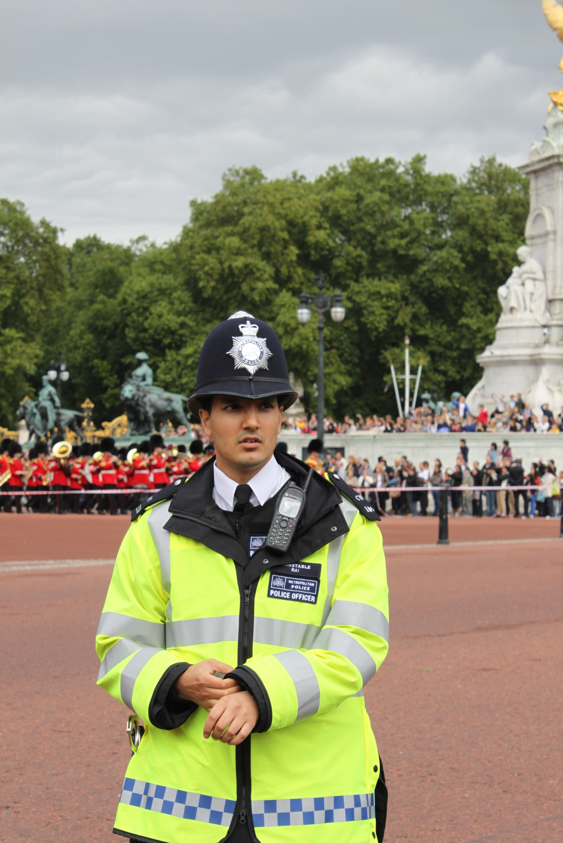
BELANGRIJK!
Je kunt:
- een gesprek netjes beginnen en eindigen.
- Fillers gebruiken. Kijk naar de woorden die onderstreept zijn. (kijk verder bij: hulp materiaal)
- woorden die je niet weet omschrijven.

Police officer: Goodmorning. How may I help you? Victim: I’d like to report a loss.
Police officer: I’m sorry to hear that. May I have your name please?
Victim: My name is Jo-anne de Vries.
Police officer: So Jo anne de Vries. Could you spell that, please?
Victim: J-o-a-n-n-e d-e V-r-i-e-s

Police officer: Tell me what happened?
Victim: Well, I wanted to buy a postcard so, so… I put my bag next to me and had a good look. After a few minutes, ehrm, I wanted to pay my wallet was gone!
Police officer: When did this all happen?
Victim: Today. Let me see, just an hour ago. I found out that my wallet was missing at about three o’clock
Police officer: I’m so sorry to hear that. Calm down, please. What was in your wallet?
Victim: Let me think.. A note of 50 euro’s. Two tickets for tonight’s concert…and a picture of my dog, which is so dear to me.
Police officer: so, a note of 50 euro’s, two tickets, a photograph. And what’s the colour of your wallet?
Victim: The colour of my wallet? It was a red one and it’s quite big. Rectangular.
Police officer: Okay I got that. Have you got any idea who stole your wallet? Did you see something suspicious?
Victim: Well, I saw a little boy walking up and down quite nervous and when I noticed my wallet was gone
the boy, kinda vanished too.
Police officer: Okay, a little boy….vanished. Could you describe the boy?
Victim: Uhm..he was about twelve, I suppose. He was wearing a white sweater with a hood. And yellow sneakers.
Police officer: Okay. Were there any witnesses?
Victim: I’m afraid not.
Police officer: That’s a shame. Well, leave your phone number and we will give you a call when we find it.
Victim: I will, thank you for your help, sir.
Police officer: You’re welcome.
AT THE POLICE STATION
POLICE STATION
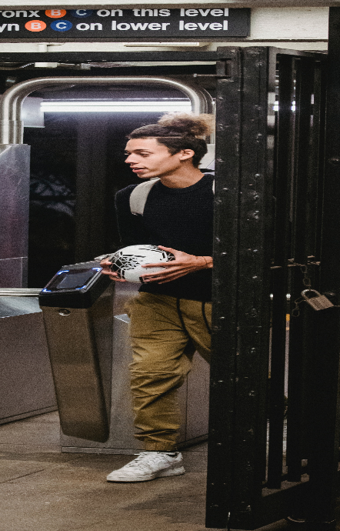
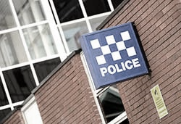
Situatie 1

SLACHTOFFER
Je bent op vakantie voor 1 week. Je bent vanmorgen met de metro( lijn 2) de stad in gegaan. In de metro liep een jongeman tegen jou aan. Hij lachte naar jou en bood zijn verontschuldigingen aan. Toen je even later jouw portemonnee uit je broekzak wilde halen was die weg. De jongen stapte bij een station uit en je bent hem gevolgd. Hij had jou in de gaten en rende weg. Je komt aangifte doen.

Probeer op alle vragen antwoord te geven. Je mag ook dingen erbij verzinnen!

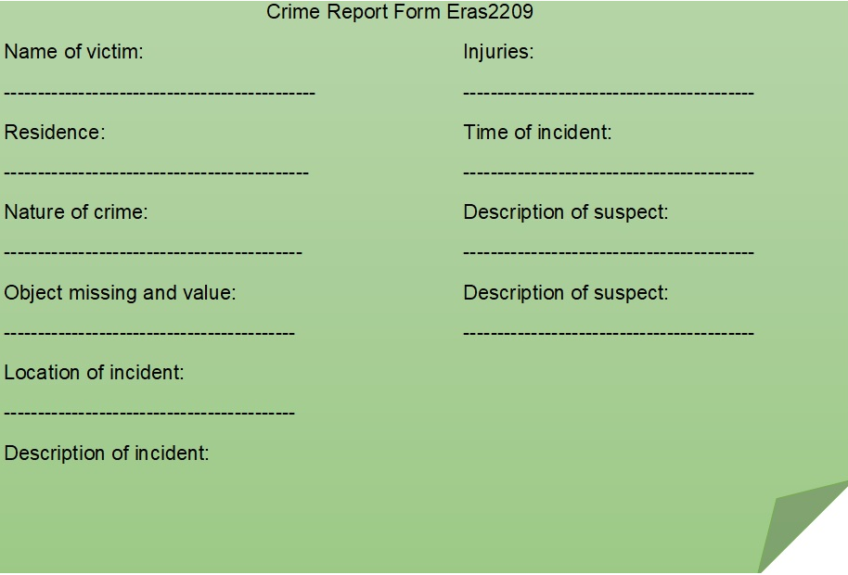
POLITIE AGENT
Jij bent een politieagent. Jouw taak is om de aangiftes in behandeling te nemen. Je hebt zoveel mogelijk details nodig. De tijd, plaats, beschrijving van de verdachte, wapens. Beschrijving wat er precies gestolen is. Of er iemand gewond is geraakt.
Probeer alle informatie te krijgen die je nodig hebt om het formulier in te vullen.

POLICE STATION
Situatie 2
SLACHTOFFER
Je liep op straat toen iemand je van achteren benaderde en je tas uit je handen greep. Je bent nog achter haar aan gerend, maar ze was te snel. In jouw tas zat een dure camera, een laptop (hp), een rode portemonnee met 200 euro en hooikoorts medicijnen.
Probeer op alle vragen antwoord te geven. Je mag ook dingen erbij verzinnen!

POLITIE AGENT
Jij bent een politieagent. Jouw taak is om de aangiftes in behandeling te nemen. Je hebt zoveel mogelijk details nodig. De tijd,plaats, beschrijving van de verdachte, wapens. Beschrijving wat er precies gestolen is. Of er iemand gewond is geraakt. De laatste tijd wordt er door toeristen veel valse aangifte gedaan zodat ze geld kunnen krijgen van de verzekering. Je arresteert altijd mensen die verdacht zijn of valse aangifte doen. Probeer alle informatie te krijgen die je nodig hebt om het formulier in te vullen.

POLICE STATION
Situatie 3
SLACHTOFFER
Je hebt zojuist 2 nachten doorgebracht in een ziekenhuis. Je had enorme pijn nadat je bij een Frans restaurant ( le petit poison) had gegeten. Je bent terug gegaan naar het restaurant om een klacht in te dienen. De manager, de kok en een ober gooiden jou uit het restaurant! De kok gooide ook nog een soepkom naar jouw hoofd.
Probeer op alle vragen antwoord te geven. Je mag ook dingen erbij verzinnen!

POLITIE AGENT
Jij bent een politieagent. Jouw taak is om de aangiftes in behandeling te nemen. Je hebt zoveel mogelijk details nodig. De tijd, plaats, beschrijving van de verdachte, wapens. Beschrijving wat er precies gestolen is. Of er iemand gewond is geraakt. P
Probeer alle informatie te krijgen die je nodig hebt om het formulier in te vullen.

POLICE STATION
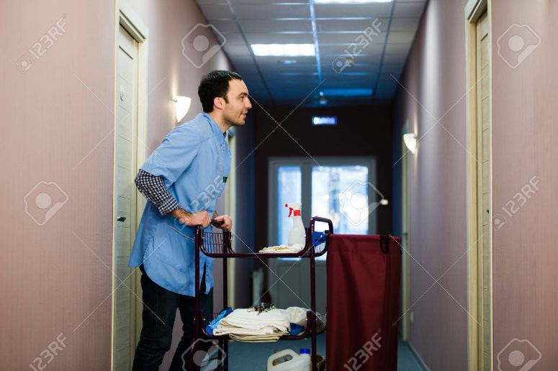
Situatie 4
SLACHTOFFER
Je verblijft in een hotel in het centrum van de stad. ( hotel Four Seasons)Nadat je vanmorgen terug kwam van het ontbijt zag je een schoonmaker in de lift stappen met een tas die sprekend op jouw tas leek. Toen je op jouw hotelkamer kwam, bleek jouw tas er niet meer te zijn. Je bent naar de manager gegaan. Die zei dat de schoonmakers nog niet waren begonnen. Je besluit aangifte te doen.
Probeer op alle vragen antwoord te geven. Je mag ook dingen erbij verzinnen!

POLITIE AGENT
Jij bent een politieagent. Jouw taak is om de aangiftes in behandeling te nemen. Je hebt zoveel mogelijk details nodig. De tijd, plaats, beschrijving van de verdachte, wapens. Beschrijving wat er precies gestolen is. Of er iemand gewond is geraakt. De laatste tijd wordt er door toeristen veel valse aangifte gedaan zodat ze geld kunnen krijgen van de verzekering. Je arresteert altijd mensen die verdacht zijn of valse aangifte doen.
Probeer alle informatie te krijgen die je nodig hebt om het formulier in te vullen.

